AIR QUALITY ANALYSIS In TAMILNADU Phase-2

# Flow chart:

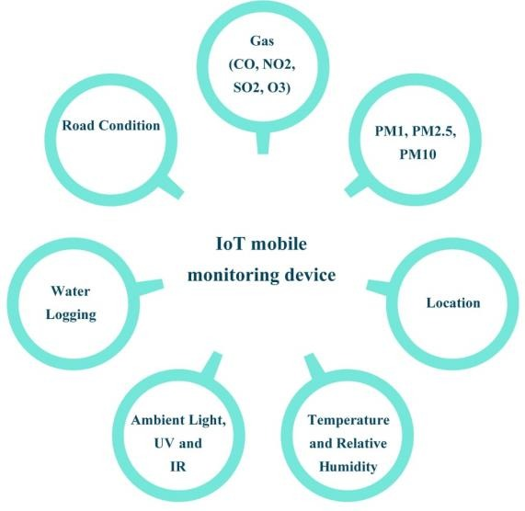

This flowchart guides the systematic process of assessing air quality, understanding the sources of pollution, evaluating its impact, and implementing measures to mitigate the effects, ultimately leading to improved air quality in Tamil Nadu.

**Start:**

* Begin with the initiation of the air quality analysis process

**Data Collection:**

* Collect data from various sources such as environmental agencies, monitoring stations, and sensors.

**Parameter Identification:**

* Identify the air quality parameters to be analyzed, including PM2.5, PM10, NO2, SO2, O3, CO, and VOCs.

**Location Specification:**

* Specify the locations in Tamil Nadu where the analysis will be conducted. This can include different cities, industrial areas, residential zones, etc.

**Data Analysis:**

* Analyze the collected data for each parameter in the specified locations.
* Use statistical methods and visualization tools to process and represent the data effectively.

**Comparison and Evaluation:**

* Compare the analyzed data against national and international air quality standards.
* Evaluate the level of pollution in each location and identify areas that exceed the permissible limits.

**Identify Pollution Sources:**

* Investigate potential sources of pollution in the areas where air quality standards are exceeded. This can include industries, vehicles, construction sites, etc.

**Impact Assessment:**

* Assess the impact of poor air quality on public health, environment, and economy. Use existing research and studies for this analysis.

**Implementation of Measures:**

* Propose and implement measures to improve air quality, such as promoting public transportation, regulating industrial emissions, and raising public awareness.

**Monitoring and Feedback Loop:**

* Implement continuous air quality monitoring systems.
* Establish a feedback loop to ensure that implemented measures are effective and make adjustments as necessary.

**END:**

* Conclude the flowchart, indicating the completion of the air quality analysis process.